CST 415 – Assignment 2
Wilsonville, Fall 2019

Create and test a simple file transfer, FT, client/server using ONE of the following:
- .NET System.Net. with C# on Windows.
- Win32 winsock2 with C++ on Windows (extra credit)
- UNIX sockets with C++ on UNIX (extra credit)

The service will be used and enhanced along with other assignments this term.
Note: This assignment assumes a working PRS is available from Assignment 1.

Server
The server application should meet the following requirements:

The server will open a TCP port that will be used to receive commands and send status information.

The server port number must be requested from a PRS, like we built in Assignment 1. Use the service name “FT Server” when requesting a port from the PRS. The FT Server port must be kept alive while being used, and closed when done.

The server must take the following command line arguments:
-prs <PRS IP address>:<PRS port>

When a connection is made, a thread should be created to process commands on that connection. While that thread is running, the server should listen for another connection.

The server can receive one of two commands from a connected client:
get\n<directory>\n
exit\n

Note commands and their parameters are always separated by a line-feed ‘\n’ character.

The get command must send all the files in the specified <directory> to the client.

You do not need to recurse to subdirectories. For simplicity, you only need to send files with the following extensions: .txt. This restriction means you don’t need to figure out if a file is a directory or not, you can filter on file name.

The exit command means the client is finished and the server can close the socket and thread for the that client’s connection. Server should continue listening for additional clients to connect.

When sending a file, the server sends the file name, file length, file contents, each separate by a line-feed \n. The length is in bytes.
A sample conversation follows:
client: get\nsome/path/dir1\n
server: file1.txt\n123\n
<server sends file1.txt’s 123 bytes of content>
server: file2.txt\n321\n
<server sends file2.txt’s 321 bytes of content>
server: done\n
client: exit\n

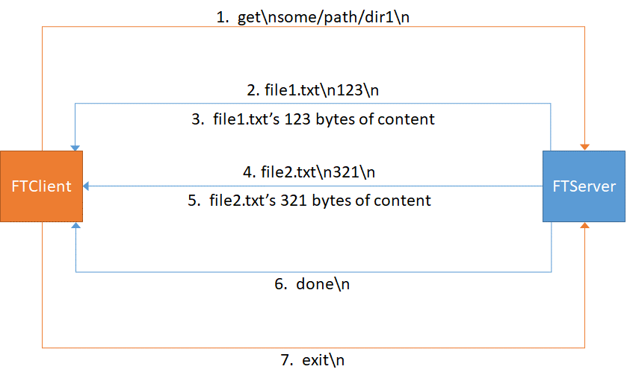

Once the server starts sending files to the client, the server will continue until all files in the directory are sent, even if it receives an “exit” command from the client in the middle of this process.

Note that “some/path/dir1” must be a valid partial path name from the server’s current working directory. If your server runs on Windows, your server will need to translate the forward-slashes /, into back-slashes \, when opening directories.

The server sends an error response if it is unable to retrieve the files in the requested directory. The word error is followed by a line feed and an error message, terminated by a line feed. For example, if the client requested the “bar” directory and that doesn’t exist on the server, then “error\nDirectory bar doesn’t exist!\n” could be the response sent to the client.

Client
The client application should meet the following requirements:

The client must take the following command line arguments:
-prs <PRS IP address>:<PRS port>
-s <file transfer server IP address>
-d <directory requested>

The client connects to the PRS at the given address:port, requests the port for the “FT Server” then connects to the file transfer server at the given server IP address and discovered port number.

The client sends a get command for the specified directory.

When the client is given a file name and file length, it receives the indicated number of bytes of file data and stores the data in a .txt file, locally with the same name.

The client creates a directory in it’s own working directory to receive the named files.

If an error is received, the client prints the error message and then disconnects from the server.

Submission
Turn in you source code in a zip file called CST415_Assign2_your_name.zip (e.g. “CST415_Assign2_Pete_Myers.zip”. The zip must include source for both client and server. The instructor should be able to compile, run and verify your program. This means you need to include your Solution/Project or Makefile as appropriate.

Handout Code
The “CST415 – Assignment 2 Handout” zip file includes the following classes. Some classes and methods are already implemented. Each method that requires implementation contains a TODO comment.

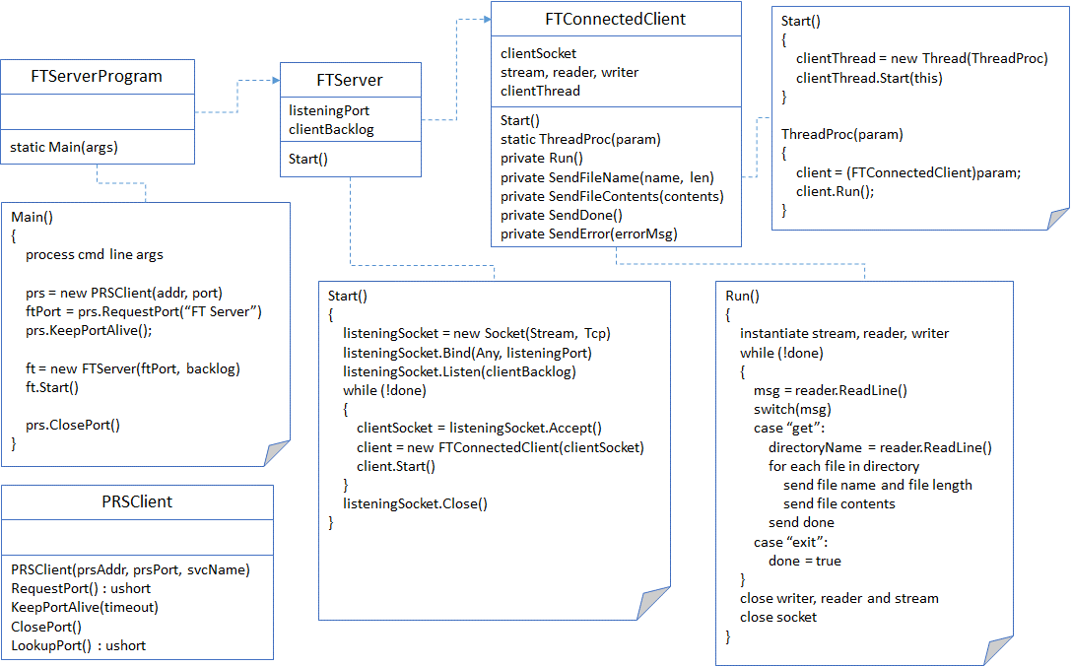

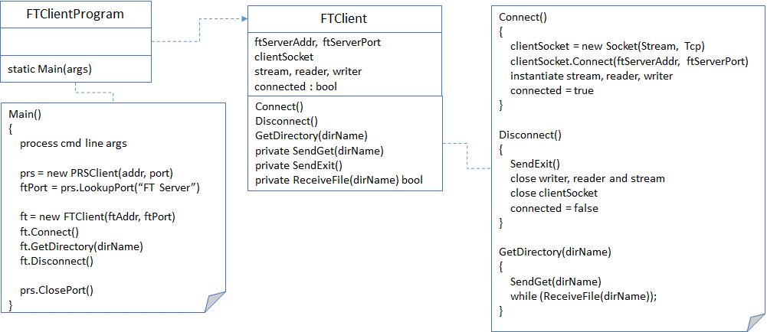

Hints

Hint 1
Use the new PRSClient class to simplify interaction with the PRSServer. You may use the PRSClient.cs file already in the Assignment 2 Handout zip file.

Hint 2
Use a NetworkStream over your TCP socket and use a StreamReader and a StreamWriter to read and write lines of text. This way you do not need to know how many bytes to allocate in a buffer when reading, and you can tell the writer to explicitly flush the output buffer:

NetworkStream stream = new NetworkStream(socket);
StreamReader reader = new StreamReader(stream, UTF8Encoding.ASCII);
StreamWriter writer = new StreamWriter(stream, UTF8Encoding.ASCII);

// receive a line of text from the other side
string line = reader.ReadLine();

// receive an expected number of characters from the other side
char [] buffer = new char[expected];
int result = reader.Read(buffer, 0, expected);
string s = new string(buffer);

// send a line of text to the other side
writer.WriteLine("get");
writer.WriteLine("some/path/dir1");
writer.Flush();

// send formatted text to the other side
string msg = "get\nsome/path/dir1\n";
writer.Write(msg);
writer.Flush();

Hint 3
In the FTServer, use Socket.Listen() and Socket.Accept() to wait for and then accept a new client connection. The Accept() method returns a new Socket for the server to use in exchanging TCP messages with the client. Allocate a new thread for each connected client. This thread will process messages for the server to talk with the connected client on its socket.

Include the thread ID in each debug message written to the console on the server. This makes debugging significantly easier as you can distringuish between messages written out by different threads.

System.Threading.Thread.ManagedThreadId.ToString()

Hint 4
Use the System.IO library in .NET to work with directories, files and paths:

DirectoryInfo .Exists, .GetFiles(), .Create()
FileInfo .Name, .Extension, .OpenText()
File .CreateText()
Path .Combine()

